1.R program to create an array of two 3x3 matrices print("Two vectors of different lengths:") v1 = c(1,4,5,8) v2 = c(1,3,5,7.9,10) print(v1) print(v2)

result = array(c(v1,v2),dim = c(4,3,6)) print("New array:") print(result)

print("The second row of the second matrix of the array:") print(result[2,,2])

print("The element in the 3rd row and 3rd column of the 1st matrix:") print(result[3,3,1]) out put:

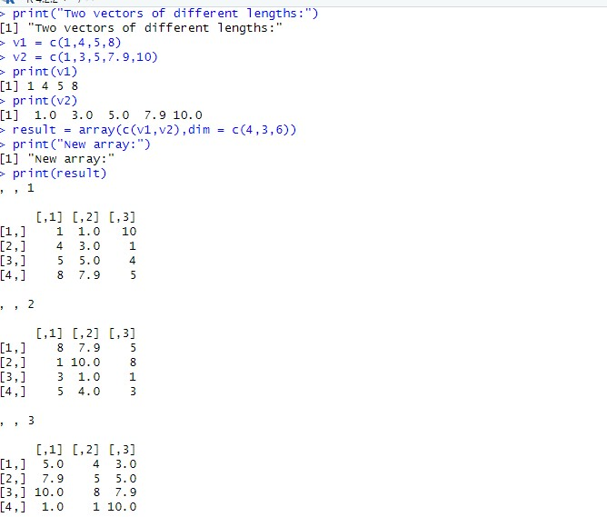

2. . Write a R program to combine three arrays so thatthe first row of the first

num1 = rbind(rep("A",3), rep("B",3), rep("c" ,3)) print("num1") print(num1)

num2 = rbind(rep("Q",3), rep("R",3), rep("S",3)) print("num2") print(num2)

num3 = rbind(rep("x",3), rep("y",3), rep("z",3)) print("num3") print(num3)

a =matrix(t(cbind(num1,num2,num3)),ncol=3,byrow=T) print("Combine three arrays,taking one row from each one by one:") print(a) out put:

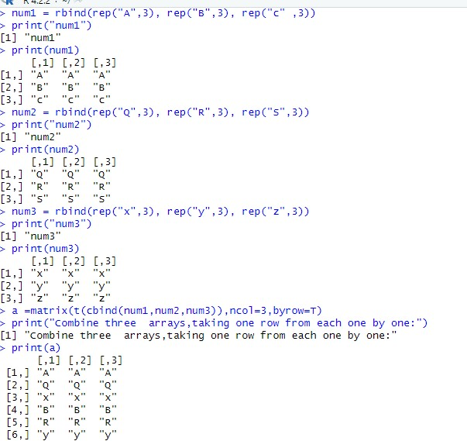

3. Write a R program to create an array using fourgiven columns array1 = array(1:30, dim=c(3,4,2)) print(array1)

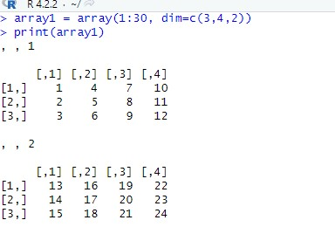

4 Write a R program to create a two-dimensional 5x3array of sequence of evenintegers greater than 50.

a <- array(seq(from = 50,length.out = 15,by = 2),c(5,3)) print("Content of the array:")

print("5*3 array of sequence of even integers greater than 50:") print(a) out put:

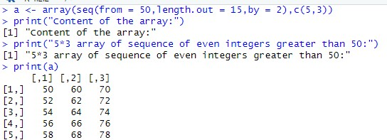

5. Write a R program to extract 3rd and 5th rows with1st and 3rd columns

exam_data = data.frame(

name = c('Anastasia', 'Dima', 'Katherine', 'James', 'Emily',

'Michael', 'Matthew', 'Laura', 'Kevin', 'Jonas'), score = c(12.5, 9, 16.5, 12, 9, 20, 14.5, 13.5, 8, 19), attempts = c(1, 3, 2, 3, 2, 3, 1, 1, 2, 1),

qualify = c('yes', 'no', 'yes', 'no', 'no', 'yes', 'yes', 'no', 'no', 'yes')

)

print("Original datafram:") print(exam_data)

print("Extract 3rd and 5th rows with 1st and 3rd columns :") result = exam_data[c(3,5),c(1,3)] print(result) out put:

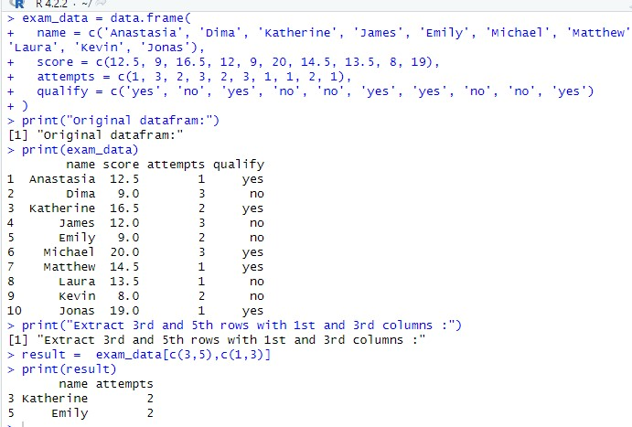

6.Write a R program to add a new column named country in a given data frameCountry<-

c("USA","USA","USA","USA","UK","USA","USA","India","USA",

"USA") exam_data = data.frame(

name = c('Anastasia', 'Dima', 'Katherine', 'James',

'Emily', 'Michael', 'Matthew', 'Laura', 'Kevin',

'Jonas'), score = c(12.5, 9, 16.5, 12, 9, 20, 14.5, 13.5, 8, 19), attempts = c(1, 3, 2, 3, 2, 3, 1, 1, 2, 1),

qualify = c('yes', 'no', 'yes', 'no', 'no', 'yes', 'yes', 'no', 'no', 'yes')

)

print("Original datafram:") print(exam_data)

print("New data frame after adding the 'country' column:")

exam_data$country =

c("USA","USA","USA","USA","USA","USA","USA","USA","USA"," USA") print(exam_data)

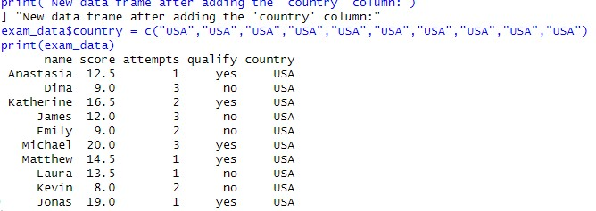 7Write a R program to add new row(s) to an existingdata frame

exam_data = data.frame(

name = c('Anastasia', 'Dima', 'Katherine', 'James', 'Emily',

'Michael', 'Matthew', 'Laura', 'Kevin', 'Jonas'), score = c(12.5, 9, 16.5, 12, 9, 20, 14.5, 13.5, 8, 19), attempts = c(1, 3, 2, 3, 2, 3, 1, 1, 2, 1),

qualify = c('yes', 'no', 'yes', 'no', 'no', 'yes', 'yes', 'no',

'no', 'yes')

)

print("Original datafram:") print(exam_data) new_exam_data = data.frame( name = c('Robert', 'Sophia'), score = c(10.5, 9), attempts = c(1, 3), qualify = c('yes', 'no')

)

exam_data = rbind(exam_data, new_exam_data)

print("After adding new row(s) to an existing data frame:") print(exam_data)

out put

:

8

Write a R program to sort a given data frame byname and score

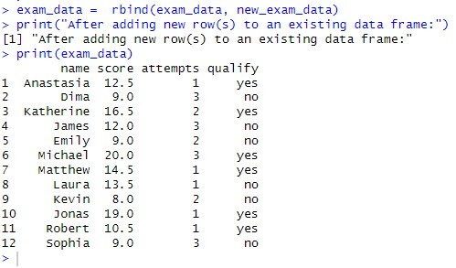

exam_data = data.frame(

name = c('Anastasia', 'Dima', 'Katherine', 'James', 'Emily', 'Michael', 'Matthew', 'Laura', 'Kevin',

'Jonas'), score = c(12.5, 9, 16.5, 12, 9, 20, 14.5, 13.5, 8, 19), attempts = c(1, 3, 2, 3, 2, 3, 1, 1, 2, 1), qualify = c('yes', 'no', 'yes', 'no', 'no', 'yes', 'yes', 'no', 'no', 'yes')

)

print("Original datafram:") print(exam_data) print("dataframe after sorting 'name' and 'score' columns:") exam_data = exam_data[with(exam_data, order(name, score)), ] print(exam_data)

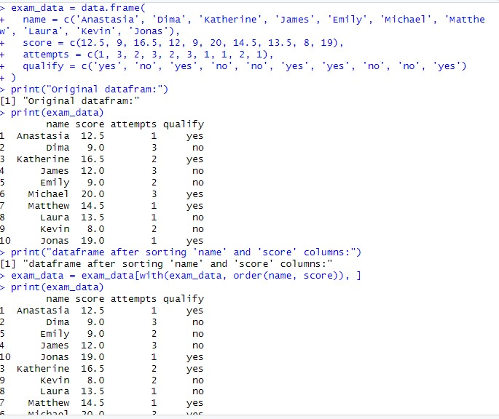

9Write a R program to save the information of a data frame in a file and displaythe information of the file.

exam_data = data.frame(

name = c('Anastasia', 'Dima', 'Katherine', 'James', 'Emily', 'Michael',

'Matthew', 'Laura', 'Kevin', 'Jonas'),

score = c(12.5, 9, 16.5, 12, 9, 20, 14.5, 13.5, 8, 19), attempts = c(1, 3, 2, 3, 2, 3, 1, 1, 2, 1),

qualify = c('yes', 'no', 'yes', 'no', 'no', 'yes', 'yes', 'no', 'no', 'yes')

)

print("Original datafram:")

print(exam_data)

save(exam_data,file="data.rda") load("data.rda") file.info("data.rda")

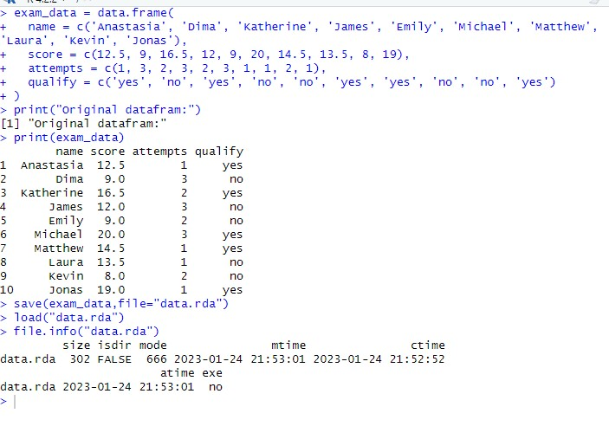

10Write a R program to call the (built-in) datasetairquality. Check whether it isa data frame data = airquality

print("Original data: Daily air quality measurements in New York, May to September 1973.") print(class(data)) print(head(data,10)) result = data[order(data[,1]),]

print("Order the entire data frame by the first and second column:") print(result)

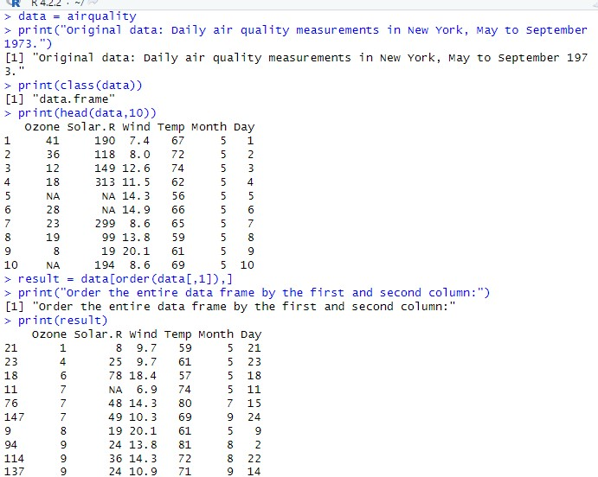

11Write a R program to create a factor corresponding to height of women data set, which contains height and weights for a sample of women.

: 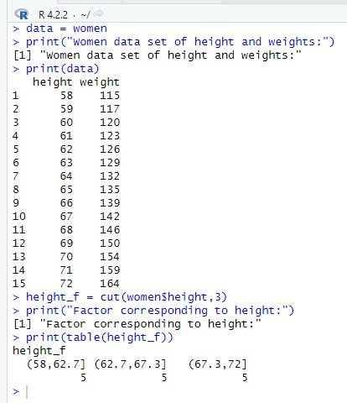

12 Write a R program to extract the five of the levels of factor created from arandom sample from the LETTERS (Part of the base R distribution.)

L = sample(LETTERS,size=50,replace=TRUE)

print("Original data:") print(L) f = factor(L)

print("Original factors:") print(f)

print("Only five of the levels") print(table(L[1:5]))

